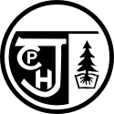
What’s Happening
At
Clayton Park Junior High
Information from teachers on outcomes and lessons they are teaching in the classroom

Clayton Park Families,

The school will be sending out information from teachers pertaining to academics that teachers are working on with students in their classrooms throughout the school year. This information is meant to communicate the outcomes that students are working towards and what they have been working on during the instructional day. This information will also be posted on our schools website under What’s New and on the Newsletter link. I hope you find this information useful and it provides an insight into what we are doing at CPJH.
Trina Canavan - Principal

Follow us on our new twitter feed @CPJHWildcats

English Language Arts

What is an author study?
Grade 9 students are participating in an author study this month! The featured author (writer, poet, artist, director and producer) is Tim Burton! Students will be given the opportunity to delve deeply into Burton’s life and body of work.
Whether individually, in small groups, or as a class, students will:
• Critically evaluate Burton’s themes, characters, and writing style
• Make connections between Burton’s life and work
• Make personal connections between their own experiences and those of Tim Burton and his characters
We really hope the students enjoy all Tim Burton has to offer!

Mathematics
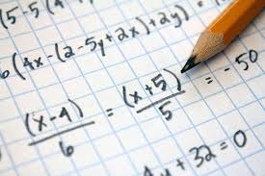

The Math Team (T. Bonnell, R. Clancey and S. Petrie) has had a busy beginning to the new school year! The Grade 7s have finished Integers and are now working on Geometry: Transformations. The Grade 8s finished Square, Square Roots and Pythagorean Theorem, with great success, and they are now working on Integers. The Grade 9s finished Exponent Laws and are now working on Operations with Rational Numbers. They are excited to start the Cake Boss Assignment next!​ Students are encouraged to take advantage of extra help sessions! Contact the teacher if you would like to know when extra help sessions are held.

Social Studies

Your social studies teachers at CPJH are Ms. Bonin (Gr. 7), Ms. MacPherson (Gr. 7). Ms. Cossett (Gr. 8) and Ms. Theriault (Gr. 8 / Gr. 9). We are off to a fantastic start this year with students engaged in many different projects and classroom activities. Students in different classes and grades have been examining topics such as empowerment, Canadian identity, and citizenship with activities including group discussion, independent research, and reflection. We have many exciting things planned. Feel free to contact your child's teacher with any questions regarding social studies.

Core French

Bonjour!

Your French teachers at CPJH are Mme. MacPherson (Gr. 7) and Mme. McCarther (Gr. 8 and Gr. 9). We are having a great year so far, with students participating in listening, speaking, reading, writing and cultural activities. We have been using a variety of authentic French resources such as music, books, recordings and videos. We are using the neuro linguistic approach to language learning. You can read more about our program on this website http://francaisintensif.ca/ . If you have any questions, please don't hesitate to contact us.
Merci​!,
Mme. MacPherson et Mme. McCarther

Visual Arts

In Visual Arts, students are using pastels and coloured pencils to create a piece of art, inspired by artworks of various Mi’kmaq artists. Stay tuned for some vibrant artwork bursting with colour decorating the bulletin board across from the office.

There are still a few spots left in Art Club which is held on Fridays at lunch. If anyone is interested see please see, Mrs. Myette. It’s a creative way to spend your lunch.

Healthy Living

Grade nine teachers have been working with students on the topic of Emotional Well being and mental health disorders. Students have investigated and presented to their classmates information about specific disorders and are developing their understanding of the importance of seeking help if people develop warning signs. Students are reminded to make arrangements to job shadow with a parent, or family friend for Take Your Kid To Work Day.
Grade 8 students (Ms. Cossett’s class) are exploring time management skills, as well as behaviours that they should avoid in order to be as organized as possible! Students are taking part in class discussions, small group activities and independent reflections on how best to manage their time at school and at home.
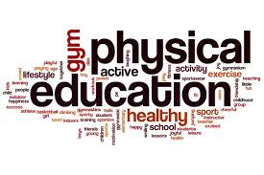
Physical Education

During the past two months we have offered our students the opportunity to develop skills of cooperation, fair play, safety, inclusion, teamwork, fitness, and skill development through low organized games, warm up activities. The students have learned active for life skills while participating in bicycling, ultimate frisbee, uninterrupted free play, soccer, and a fitness test. They demonstrated movement skills, transition skills from offensive to defensive and back and forth between them during game play. The students here at CPJH are actively engaged in skills and class participation. We look forward to watching their development throughout the year!
The grade 8 students participated in Geocaching on November 1st and November 2nd They attended the Natural Resources Education Centre in Middle Musquodoboit, NS to participate in Geocaching.

Fine Arts Specialist

Clayton Park is fortunate to be the homeschool for two Art Specialist Ms. Jensen and Ms. Morris with the Halifax Regional Center for Education. The Art Specialists work with 12 schools throughout HRCE and have been collaborating with teachers on incorporating art within subject specific outcomes. They have been in classrooms co-teaching with teachers throughout the past two months and will continue this collaborative and integrated approach throughout the school year. Stay tuned for more exciting art and subject-based lessons.

Thanks to Ms. Petrie for inviting me to do some hands on math with grade 8 classes this month. We used the basic concepts of Pythagorean theory to calculate, measure and cut squares of foam in progressively smaller sizes to form a fractal pattern. This pattern can be found in nature resembles trees and plants grow when put together. When glued down, they reveal the Pythagorean triangles in the centres. When added all together we created two large trees that are currently on display in the hall. – Ms. Jensen Fine Arts Specialist-VISUAL ARTS
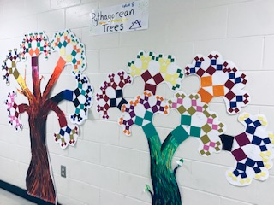

We Act Group

The We Act group is off to a great start planning a variety of fundraising and charitable activities for this year. On Oct 15th eighteen students from the We Act group were able to attend a Mini We Day event held at the Rebecca Cohen. This was an inspiring afternoon for them and they got to hear about the We organization from the man to started the charity, Craig Keilburger. They were fortunate enough to hear from some of the guest speakers who have attended the large We Day event, and local students who shared how they tackled their local and global goals. To finish they got to see a rising local talent Neon Dreams preform, which left students excited about their experience. A warm thank you to our parent volunteers for driving students down, without you this couldn't have happen!

Students Of The Month for September & October

We will also be recognizing our students of the month. Teachers will submit student names who they feel deserve to be recognized for outstanding leadership and good citizenship throughout the month.

Congratulations to the following students for being Students Of The Month

September
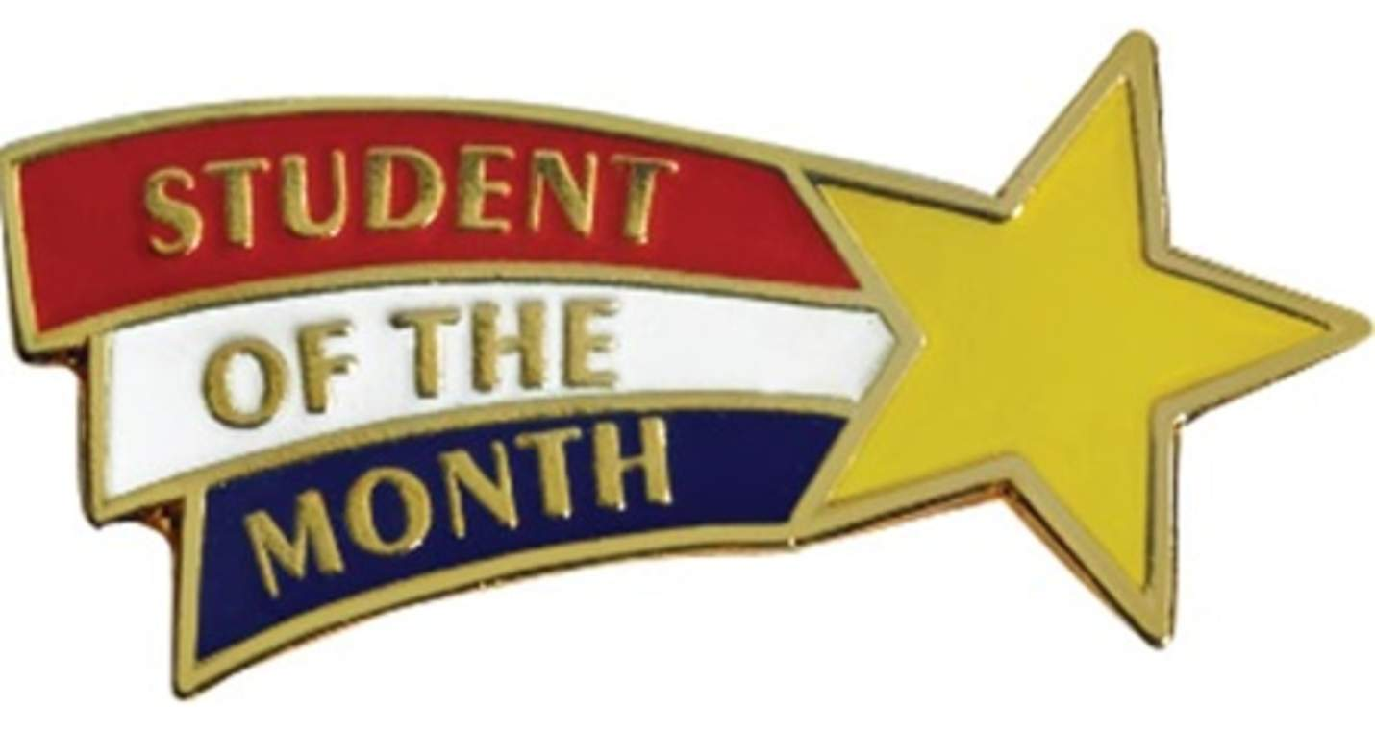
Anna Martin – Grade 7
Sophie Strong – Grade 8
Ashley Spicer – Grade 9

October
Riley Beazley – Grade 7
Will Robinson – Grade 8
Aisha Sulyman – Grade 9

Stay tuned for many more great edcuational news that is taking place at CPJH!

