What’s Happening
At
Clayton Park Junior High
Information from teachers on outcomes and lessons they are teaching in the classroom

Clayton Park Families,

The school will be sending out a “What’s Happening” newsletter on a quarterly bases pertaining to academics and what teachers are working on with students in their classrooms throughout the school year. This information is meant to communicate the outcomes that students are working towards and what they have been working on during the instructional day. This information will also be posted on our schools website under What’s New and on the Newsletter link. I hope you find this information useful and it provides an insight into what we are doing at CPJH.
Trina Canavan - Principal

Follow us on twitter @CPJHWildcats

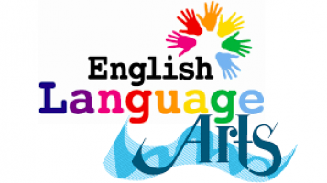

Ms MacLean’s grade 7 students have been reflecting on who they are; as people, students, classmates, friends and family members. Everything we have been doing is getting us ready for the creation of a tattoo sleeve design. We have also been working on formulating personal responses to literature and learning to support our opinions through evidence from the text we are reading.
- Ms. MacLean

Mr. Langille’s Grade 7 English Language Arts classes have worked on engaging and establishing practices and routines in class. Students have explored and reflected on their personal experiences, and thought of significant items in their lives. They considered objects that have helped to shape their memories and beliefs, and how these have moulded the way they think. The end goal was to gain a better idea of where they came from, how it shaped them, and how figurative language can be utilized to convey their message through poetry. Students have since begun a unit on short stories, exploring elements of plot, characterization, conflict and theme.
- Mr. Langille

Ms MacLean’s grade 8 students have been immersed in memoirs. We have read several examples together and students have been writing their own. Students are working individually and in small groups to craft interesting pieces of writing. We have also been listening to music and creating writing and artwork to compliment each piece of music. Seeing the variety of interpretation in each class is very interesting.
- Ms. MacLean
As the school started, Grade 92/93 students spent time getting to know each other through a 5 Paragraph "All About Me" assignment. Students used imaginative language and interesting word choice to create and display an informative piece of writing. We loved reading each other's work and learning about what makes all of us unique and special!
What is an author study?
Grade 92/93 students are participating in an author study this month! The featured author (writer, poet, artist, director and producer) is Tim Burton! Students will be given the opportunity to delve deeply into Burton’s life and body of work.
Whether individually, in small groups, or as a class, students will:
• Critically evaluate Burton’s themes, characters, and writing style
• Make connections between Burton’s life and work
• Make personal connections between their own experiences and those of Tim Burton and his characters
• Create poetry and characters in the style of Burton’s work
• Visit the Fine Arts Lab at Rocky Lake Junior High to make Tim Burton pottery!
We really hope the students enjoy all Tim Burton has to offer!
- Ms. Learning

Mr. Langille’s Grade 9 English Language Arts classes have worked on engaging and establishing practices and routines in the classroom. Students have written detailed and structured letters, expressing significant aspects of their lives, as well as their memories, beliefs and values. From these lessons, students have gained a better understanding of who they are, their strengths, challenges, and interests as well as how both language and structure can be utilized to convey their message. Students have recently begun a short story unit, exploring literary elements and language.
- Mr. Langille

Mathematics
The grade 7s have finished Adding and Subtracting Integers and are currently working on Transformational Geometry: Translation, Reflection and Rotation of polygons. The grade 8s have finished Squares, Square Roots and the Pythagorean Theorem we are now working on Multiplying and Dividing Integers using a variety of different methods. The grade 9s have finished Exponents and are now working on Rational Numbers. Students require graph paper and a math set for class.
A reminder to parents that if their child is having difficulty in math, practicing basic mathematical operations, facts and concepts at home, 3 evenings a week for 15 minutes each evening could improve your students ability.
- Ms. Bonnell, Mr. Clancey, Mr. Alassad

In Mr. Langille’s Grade 7 Social Studies class, students have been exploring a unit on empowerment. Through their responses to various texts and images, with whole class and small group discussion as well as written work, they have inquired into how power and authority affects people's lives, types of empowerment, and how power and authority is used in society.
- Mr. Langille

Ms. Theriault’s grade 7 Social Studies classes have completed the introduction to Empowerment and are working on the Economic Empowerment unit. Students have learned about the First Nations people who had first contact with early European settlers. They have learned about the valuable resources that the First Nations used as their traditional economy and how first contact impacted their economy after settlement.
- Ms. Theriault
Mr. King's Grade 8 Social Studies class has been exploring Canadian Identity by looking at the symbols and stereotypes associated with Canada and Canadians. We have looked at visual art, music, and literature produced by a wide range of Canadian artists and looked for connections with the various aspects of Canadian Identity. Students are currently researching a Canadian artist or writer of their choice and will be sharing their findings with classmates in the near future.
- Mr. King
Grade 8 Social Studies Students were introduced to the five parts of Canadian Identity. They were introduced to artists, musicians and writers of various Canadian backgrounds. To end the unit they worked on a research assignment of a famous Canadian (of their choice) who fell into one of the categories mentioned before.
- Ms. Theriault

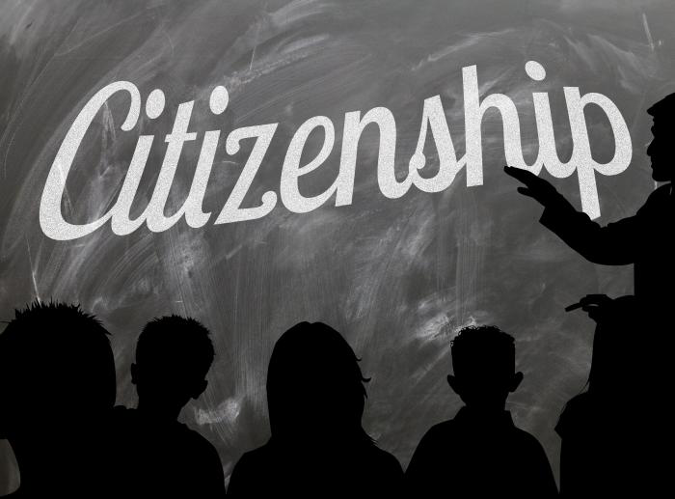
Mr. King's Grade 9 Citizenship Education class has been learning about our government and followed the 2019 Federal Election closely. We compared the parties, their leaders, platforms, and evaluated the English language debates before participating in a Student Vote. We have also been discussing what governments do, how policies are created, and the avenues available to have your voice be heard in a democracy. Moving forward, we will continue to deconstruct the results of the 2019 Federal Election and use them to further develop our understanding of government and citizenship.

- Mr. King

Ms. Theriault’s Grade 9 Citizenship class just completed the first unit on Government and covered the election. We've learned about the levels of government and responsibilities of each level. Students will begin planning for their service learning projects and we'll be looking at digital citizenship as well.
- Ms. Theriault

Core French

Bonjour!
Was wonderful to come back in September and see all the familiar faces! The grade 9s have jumped back in and are doing some review of grammar and structures learned last year. The grade 8s have quickly learned the routines in French class and have had many opportunities to impress me with their French skills. In October we are currently sharing all the things we are thankful for, have been working in our journals, and with the inspiration of Halloween, we have enjoyed a monster themed French film!

Merci beaucoup!

- Mme McCarther

After studying the advantages tied to learning additional languages, the students in Mr. King's grade 7 Core French jumped right into learning the language. They have been learning to speak and write about their past time in French. We have also been playing games and reading books (in French of course) on the same subject to develop our vocabulary. Students have been eager to learn and are rising to meet the challenge when we go full "French Mode". Students will continue investigating past time deep into Term 1 while also developing their everyday phrases associated with dates, weather and other interests.
- Mr. King

Visual Arts

In Visual Arts 7 we have been exploring Mixed Media. We’ve been taking time to work with a variety of materials, then combining them in new and interesting ways. We’re mixing drawing, painting, collage and more to create artwork inspired by both contemporary artists as well as artists from history.
In Visual Arts 8 we’ve been focusing on different drawing styles. Working with abstract, line doodles, cartooning and realism we’ve been exploring a wide range of artistic methods and influences. We’ve been challenging ourselves to step outside of our comfort zones and try a variety of new things.
In Visual Arts 9 we’ve been exploring nature and the built environment. By exploring the work of contemporary sculptors, architects and designers, we're investigating how artists can impact our physical surroundings. We’ve also examined how this can relate to our everyday lives, examining artistic spaces created for a wide array of purposes including parks, libraries, churches, movie sets and more.
All art classes have also have had the opportunity to learn about and participate in Inktober 2019! This international online art challenges lasts all October and gave students the opportunity to see what local, national and international artists are creating right now as a community.
- Ms. Delaney

In Grade 7 Healthy Living we have been building class relationships with our new Grade 7 students and many have adjusted well to their new Junior High routines. It has been fun getting to know each other over the last few weeks. In class we have been covering values, goals and goal setting. Currently we are looking at skills and interests and how they fit into their future educational goals.
- Ms. Toulany & Ms. Buckle

In Mr. Christian’s Healthy Living class, students started off the year learning about the importance of values and how they shape us as individuals. Students were able to figure out which values are the most important to them and discovered where these values came from. Students then discussed goal setting and had the opportunity to form some short-term goals to accomplish their long term ones. Currently, students are still exploring goal setting through researching about a career that they are interested in doing someday. Students are finding out information specific to those careers to figure out what they need to do in order to potentially follow that career path someday.

- Mr. Christian

Mr. Crocker’s Healthy Living grade 8 classes began the year discussing Body Image in teens - these topics involve media impact on teen’s self esteem and body image, as well as eating disorders. We have watched several videos relating to these subjects, and had extensive discussions on this topic, as well as discussing how it impacts all young people on the gender spectrum. The next topics covered will be on values and mental health/depression
- Mr. Crocker

Ms. Theriault’s grade 8 Healthy Living students have learned the difference between Major Depressive Disorder and Attention Deficit Disorder as well as the problems with delayed treatment. They have learned about how quickly and easily it is to lose control of information on the Internet and the issue of cyber bullying. Students have recently been working on evaluation of time and tips on how to manage their time.
- Ms. Theriault

Mr. Crocker’s grade 9 Healthy Living classes began the year discussing mental health. We touched on the different aspects of mental health, the different types and what factors influence their development. Students are currently completing mental health activities, which identify risk factors and symptoms/treatments for various mental illnesses. They will next be moving to presentations on the same topic, and the next unit will be Addictions.
- Mr. Crocker

It was nice to see the Grade 9 classes and how they have grown since Grade 7! In Grade 9 Healthy Living students looked at coping with change and resilience. The topic of Mental Health will be covered next.
- Ms. Toulany

Physical Education 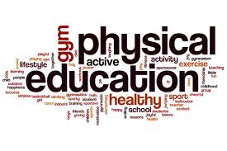
What’s happening in Physical Education!!
Mr. MacNeil's grade 7 Phys Ed class has been off to a busy and exciting start. 73 started out the year playing and learning all kinds of low organized games. These games have helped the students really get to know each other and were a great introduction to what Junior High Phys Ed is all about. 73 has also begun their on-going fitness component to Phys Ed as each student has completed a beep test and will be encouraged to continue working on improving their scores as the year goes on. Students have finished an extensive soccer unit where they learned the importance of sportsmanship, team play and the development of skills. This wonderful group is excited to start their next unit​.
- Mr. MacNeil
It's been a busy couple of months for Physical Education students both inside and outside of the gym. The Grade 7, 8, and 9 students started off the year with different low organized games so they could get used to the new combinations of students and to learn the expectations around inclusion, fair play, safety, teamwork, and persistence. They also did a Fitness Test to get a baseline score for the Grade 7’s and the 8’s and 9’s are looking at how they have done with their fitness since the spring of last year. The grade 7’s and 8’s worked on soccer and football skills using a progression from passing and receiving the ball to patterns, to get open on offence and covering a player on defence. They started with modified games such as 4 Corner Soccer, End Zone, Ultimate Frisbee and Scooter Handball transitioning to games of Soccer and Touch Football. The Grade 9’s spent time learning and playing the game of Volleyball with serving and forearm passing as the main components and then playing games to put the skills into action. The grade 7 and 8 students are now in the middle of Touch Football and beginning Volleyball. The Grade 9 students will be starting a Fitness unit. We are hoping the weather continues to cooperate! Our Grade 8 Physical Education students went to Musquodoboit in November for a Geocaching experience and learning skills of navigation, safety, and how to be safe in the woods while still enjoying activity, being friendly to the earth by not leaving a trace (no garbage left behind), inclusion and fair play by sharing and making sure their classmates learn in small groups!​
- Mr. Norris & Ms. Buckle
Mr. Norris' and Ms. Buckle's Grade 7 Science classes have been busy learning all about Ecosystems over the last 2 months. Students had the opportunity to do a School Yard Investigation and to take a look at the living and the non-living in our school yard neighborhood. Then we were off to Middle Musquodoboit to go out in the wilderness and explore grassland and forest ecosystems and some of the Biodiversity found in Nova Scotia! They had an opportunity to measure the temperature of the ground and to discuss what affects the temperature has on the growth in the forest. They bore into a tree to look at the age and the rings of the trees and explore what each year’s growth looked like and what may have influenced the growth. The students also looked at a core sample of the ground while looking at what it is composed of and what the contents of the soil sample indicates about what things grow best in that environment. Students in Mr. Norris’ classes have enjoyed creating their own Endangered Species and will continue to learn about the roles different organisms play in our ecosystems and everyday lives. Ms. Buckle’s class will be creating a board game as a final project on Ecosystems to demonstrate their knowledge of Ecosystems and Biodiversity.
- Mr. Norris & Ms. Buckle

The grade 8’s have been learning about water systems and the relationship that water has with land. They started off the year studying the water cycle and created some awesome comics around what happens to water as it goes through the cycle and returns to the Earth’s surface. From there, students have been learning about the hazards of flooding and erosion, while also considering how hazardous threats will be for people who live near the coast through the lens of climate change. Students are currently reading about some protection strategies that coastal communities could possibly be using to protect their areas of interest from flooding and erosion. Students will then be finishing off the unit by learning about the role that ocean currents and glaciers play in contributing to the climates of areas around the world and how climate change can impact both.
- Mr. Christian

The grade 9’s have started off the year working within the chemistry unit, where they first started reviewing the WHMIS symbols and the dangers that each symbol warns of. From there, students spent some time in the lab working with various substances to practice identifying physical properties. They then mixed certain substances together to figure out whether a physical or chemical change occurred. Currently, students are beginning to study Atomic Theory and are inching closer and closer to finally working within the Periodic Table. Once students have practiced working with the Periodic Table, they will then begin to look at chemical formulas and the types of bonds that hold these formulas together.
- Mr. Christian

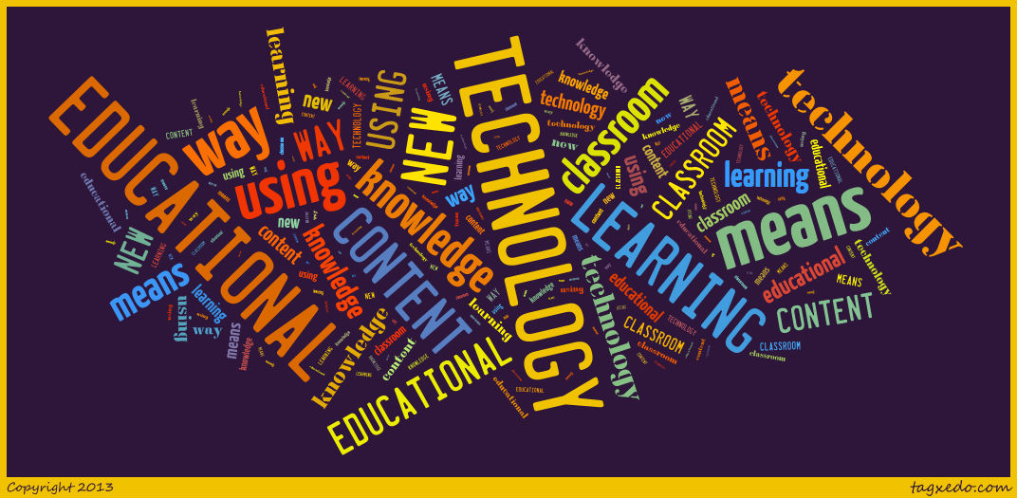
In Technology Education the 7s are just wrapping up their tin foil boat introductory activity, and the 8s are finishing their paper cars. I have been asking the 9s to bring in recyclable material like pop or milk cartons, laundry soap bottles, etc for a project that reuses various recyclables for different purposes. As a reminder please have your son or daughter bring some of these items in for their project. After these introductory projects, all classes will be transitioning to the safety tests, though most 9s have completed them already. From there the 7s will move to their first project, a wood cube puzzle, the 8s will start design work on their C02 cars, and the 9s have begun design work for their Smart Phone Holder.
- Mr. Crocker

Family Studies
Students are quickly adjusting to the new 10 day rotating schedule. We are in the beginning stages of the program and the Grade 7 classes have started their basic hand-sewing skills. Most have mastered threading, knotting and a couple of basic stitches. In Grade 8 we have been covering the topics of food and kitchen safety and hopefully in the next few weeks will be doing food labs. Grade 9 classes have been introduced to child development and motor skills. We are currently on the topic of Child Safety and Childproofing. Time certainly is flying by fast and Term 1, being a fairly short one, will be over in a blink of an eye.
- Ms. Toulany

Students of The Month for September & October

We will also be recognizing our students of the month. Teachers will submit student names that they feel deserve to be recognized for outstanding leadership and good citizenship throughout the month.

Congratulations to the following students for being Students Of The Month

September
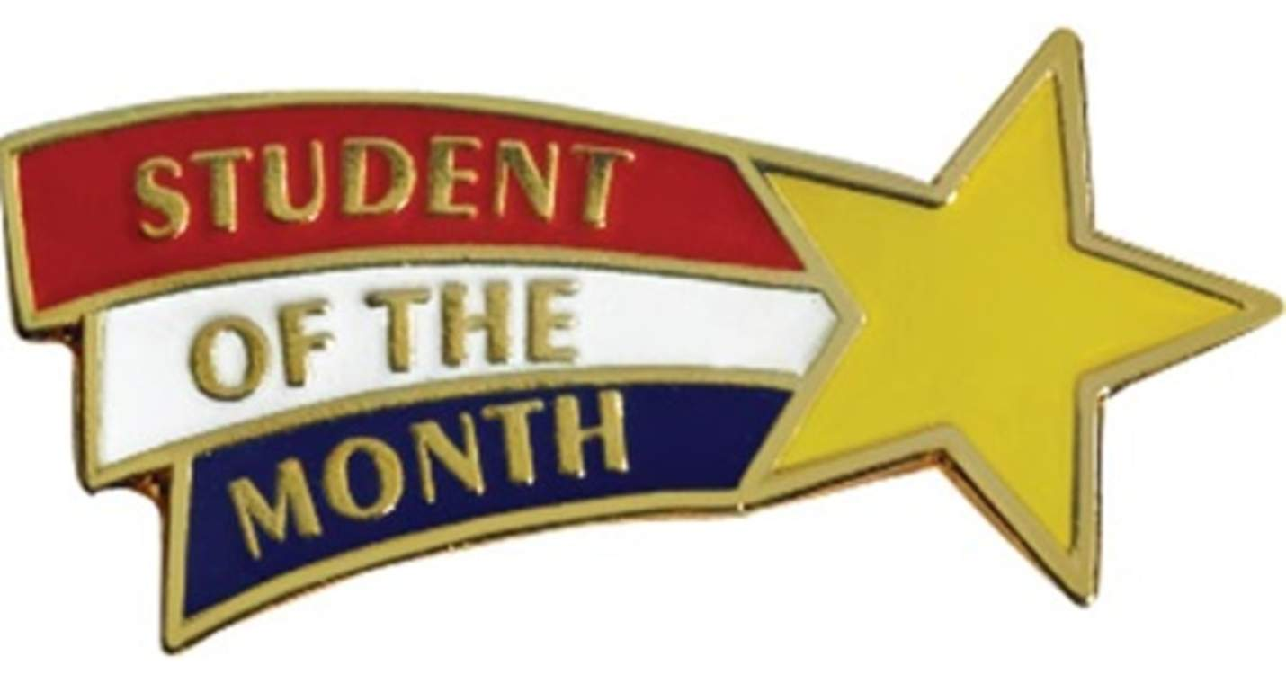
Abeesha Duaa – Grade 7
Catherine Coldwell – Grade 8
Sabrina Oyshi – Grade 9

October
Estella Vale – Grade 7
Rachel Budgell – Grade 8
Nick Kinley – Grade 9

Stay tuned for many more great edcuational news that is taking place at CPJH!

