CPJH Parent Teacher Dec 3rd 1 – 5pm

This year we will be conducting a phone parent teacher conferences on Dec 3rd from 1pm to 5pm. To ensure all families have an opportunity to speak with their child’s teacher, please pay close attention and follow the instructions for making an appointment. Booking appointments will be available until December 3rd at 10am.

Instructions for Making an Appointment

- To make an appointment with each of your child’s teacher’s click on the link provided in the table below.
- Only book one appointment time slot per teacher. Each appointment is 8 minutes.
- Make sure to go to Dec 3rd to make an appointment
- Select one time slot for your conference
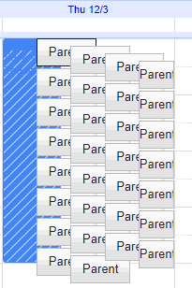
- Please include the following in the description. Parent Name, Students Name and Homeroom and Your Phone Number. Remember to save.

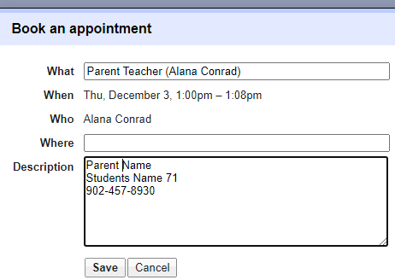

- You will be sent an email invitation for your appointment confirming your teacher meeting with the appointment time. Please keep for your records.

In the chart below is a list of your child’s teacher and the subjects they teach. There is a link for each teacher that will take you to their Parent Teacher Appointment Calendar.

Teacher | Subjects | Appointment Calendar
Mr. Alassad | 82, 84, 92, 94 Math | Mr Alassad Parent Teacher
Mr. Aldred | 72, 75,81, 83 Math | Mr. Aldred's Parent Teacher
Mr. Clancey | 71, 73, 91, 93 Math | Mr Clancey Parent Teacher
Mr. Conrad | 72, 74, 76, 82, 84, 92, 94 Phys. Ed  71, 75 Science | Mr Conrad Parent Teacher
Mr. Crocker | 7-9 Tech. Ed  71, 72, 76 Healthy Living | Mr Crocker Parent Teacher
Ms. Houston-Goudge | 75, 76, 82, 84 Social Studies  74, 91, 92 Healthy Living | Ms. Houston-Goudge Parent Teacher
Mr. Huskins | 7-9 Band | Mr Huskins Parent Teacher
Mr. King | 72, 73, 74, 76 French  91, 92, 93, 94 Social Studies | Mr King's Parent Teacher
Mr. Langille | 71, 73, 92, 93 ELA | Mr. Langille Parent Teacher
Ms. Learning | 81, 84, 91, 94 ELA | Ms. Learning Parent Teacher
Mr. Masotti | 7-9 Art | Mr Masotti​ Parent Teacher
Mr. MacBurnie | 74, 75 ELA and 72, 73 Social Studies  81, 83 Healthy Living | Mr. MacBurnie Parent Teacher
Mme. McCarther | 8-9 French | Mme McCarther Parent Teacher
Mr. MacDonald | 74, 76 Math  82, 83, 92, 94 Science | Mr. MacDonald Parent Teacher
Mr. MacKenzie | 71, 74, 81, 83 Social Studies  82, 93, 94 Healthy Living | Mr MacKenzie Parent Teacher
Ms. MacLean | 72, 76, 82, 83 ELA | Ms MacLean Parent Teacher
Ms. Milligan | Learning Centre | Ms. Milligan Parent Teacher
Mr. Norris | 71, 73, 75, 81, 83, 91, 93 Phys. Ed  72 Science | Mr. Norris Parent Teacher
Ms. Panopalis | Resource | Ms Panoplais Parent Teacher
Ms. Tawil | 73, 74, 76, 81, 84, 91, 93 Science  71, 75 French | Ms.Roula Tawil Parent
Ms Thompson-Willows | EAL | Ms. Thompson-Willows Parent Teacher
Ms. Toulany | 7-9 Family Studies  73, 75 Healthy Living | Mrs. Toulany Parent-Teacher
Ms. Ugursal | Student Intervention | Ms Ugursal Parent Teacher

