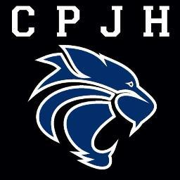**Administrative Staff**

**Welcome to**

**Clayton Park Junior High**

**2021 2022**



**Mrs. Trina Canavan**

**Principal**

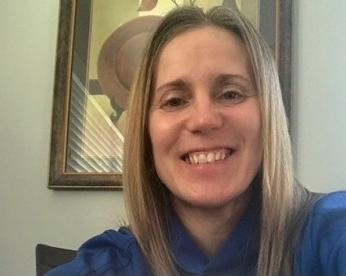

**MS. Alana Conrad**

**Vice Principal**



**Ms. Erica Reid**

**Administrative Assistant**